Explain PROBABILITY MASS FUNCTION (PM F) and PROBABILITY DENSITY FUNCTION (PDF). and what is the difference between them?

2/2

**Probability Mass Function (PMF) and Probability Density Function (PDF)** are fundamental concepts in probability theory and statistics, used to describe the distribution of discrete and continuous random variables, respectively.

### **Probability Mass Function (PMF)**

* **Definition**: The PMF is a function that gives the probability that a discrete random variable is exactly equal to some value. It applies to discrete random variables, which take on a countable number of distinct values.
* **Formula**: For a discrete random variable X with possible values x1 ,x2 ,…,xn , the PMF is defined as:

*P(X=xi)=p(xi)*

Where *p(xi)* is the probability that the random variable *XX*X equals *xi .*

* **Properties**:
  + *0≤p(xi)≤1*
  + *∑ip(xi)=1*
* **Example**: Consider a fair six-sided die. The PMF for the die roll *XX*X is:

P(X=x) = {1/6 , if x∈{1,2,3,4,5,6}

{ 0 , otherwise

### **Probability Density Function (PDF)**

* **Definition**: The PDF is a function that describes the relative likelihood for a continuous random variable to take on a given value. Unlike the PMF, the PDF applies to continuous random variables, which can take on an infinite number of values within a given range.
* **Formula**: For a continuous random variable X with a PDF f(x), the probability that X lies within a certain interval [a,b] is given by the integral of f(x) over that interval:

P(a≤X≤b)=∫ab f(x)dx

* **Properties**:
  + f(x)≥0 for all x
  + ∫−∞∞ f(x)dx=1
* **Example**: Consider the standard normal distribution with mean 0 and standard deviation 1. The PDF for the standard normal distribution *XX*X is:

f(x)=2π 1 e−2x2

### **Differences Between PMF and PDF**

1. **Type of Random Variable**:
   * **PMF**: Used for discrete random variables.
   * **PDF**: Used for continuous random variables.
2. **Probability Calculation**:
   * **PMF**: Directly gives the probability of the random variable being exactly equal to a specific value.
   * **PDF**: Gives the relative likelihood of the random variable taking on a specific value, but the actual probability of the variable taking an exact value is zero. Instead, probabilities are calculated over intervals.
3. **Summation vs. Integration**:
   * **PMF**: Probabilities are summed over the possible values of the random variable.
   * **PDF**: Probabilities are integrated over a range of values.

### **Visualization**

* **PMF**:

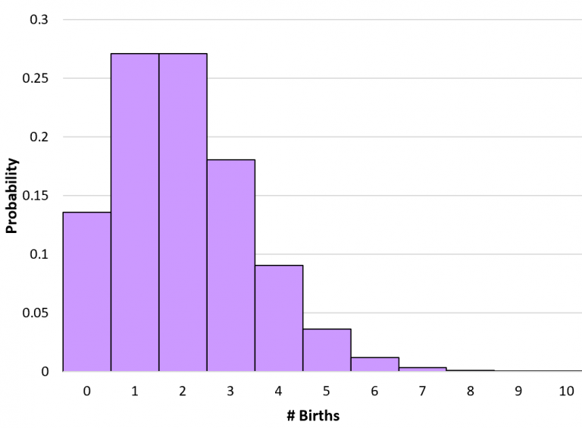

The graph shows a discrete random variable with specific probabilities for each value.

* **PDF**:

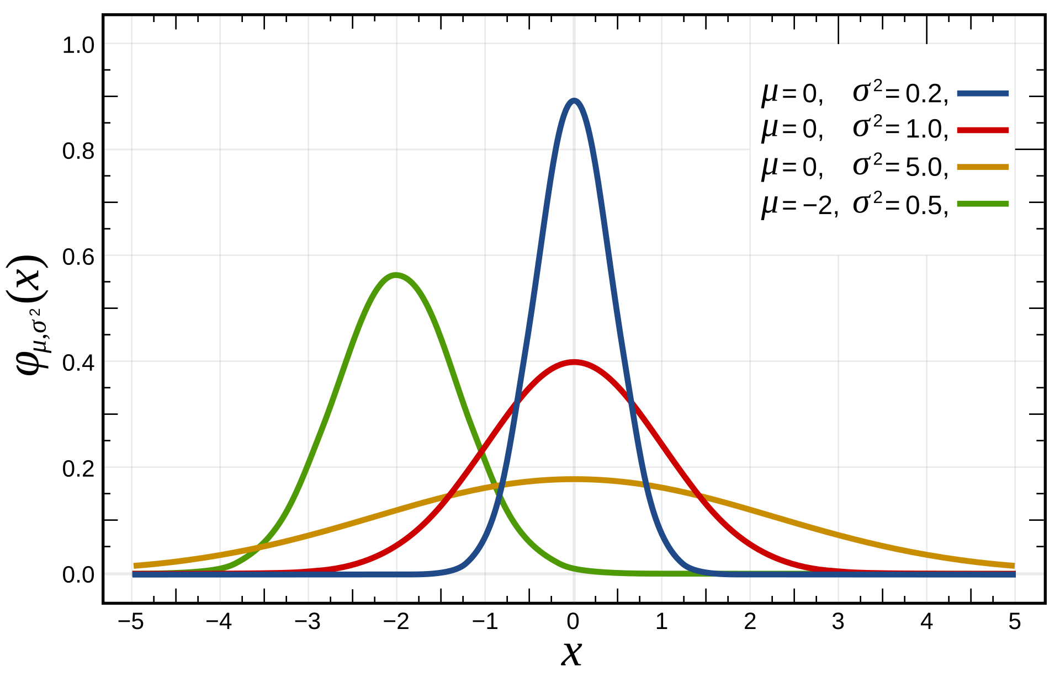

The graph shows a continuous random variable, where the area under the curve between any two points represents the probability of the variable falling within that interval.